TestNG

How to create a TestNG project?

Create a maven project

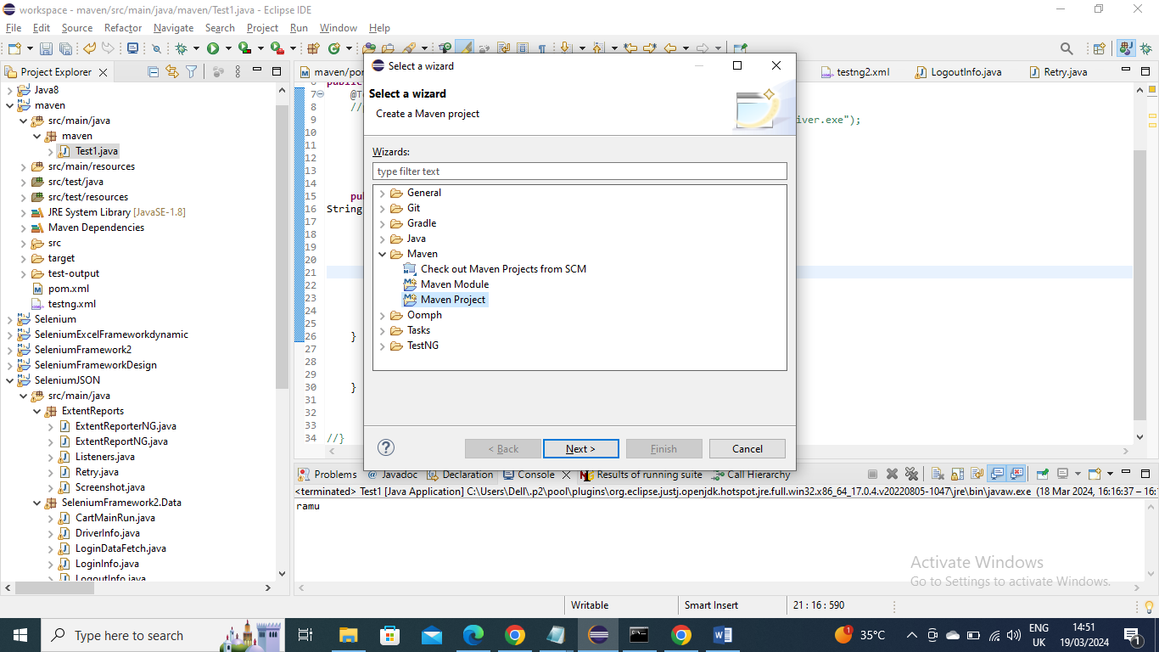

Select “create a simple project(skip archetype selection)

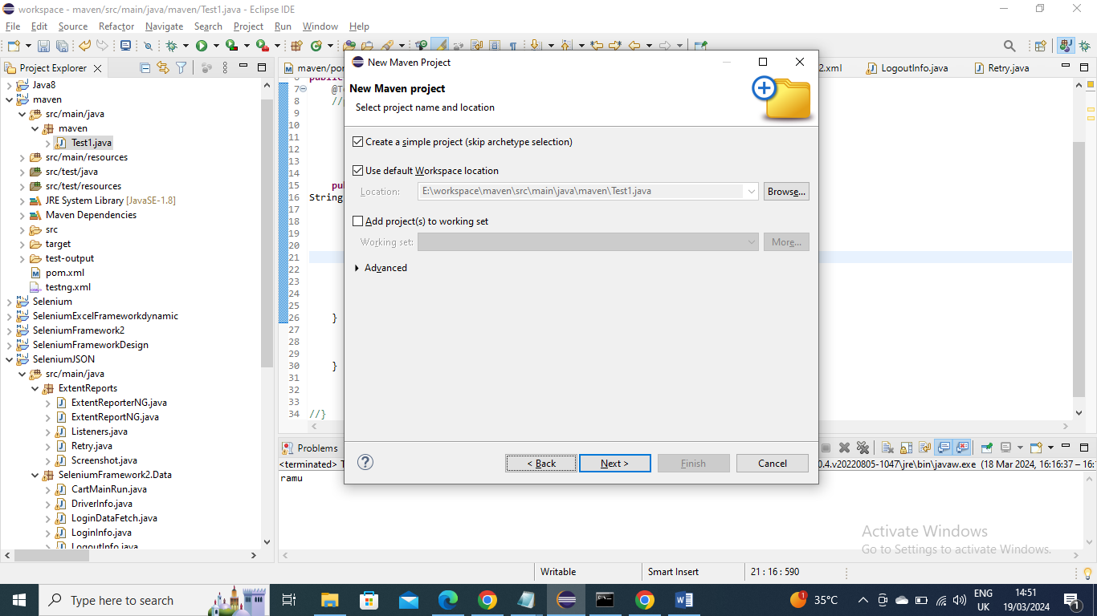

Give Artiact id(Project name) and Group ID and give finish

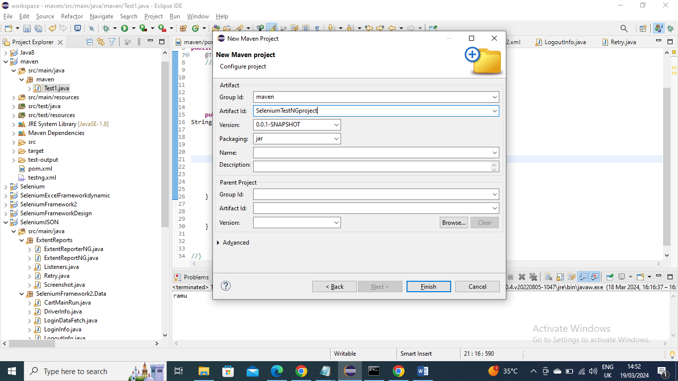

Right click on project and got to TestNG and then “convert to TestNG” and then next next and finish

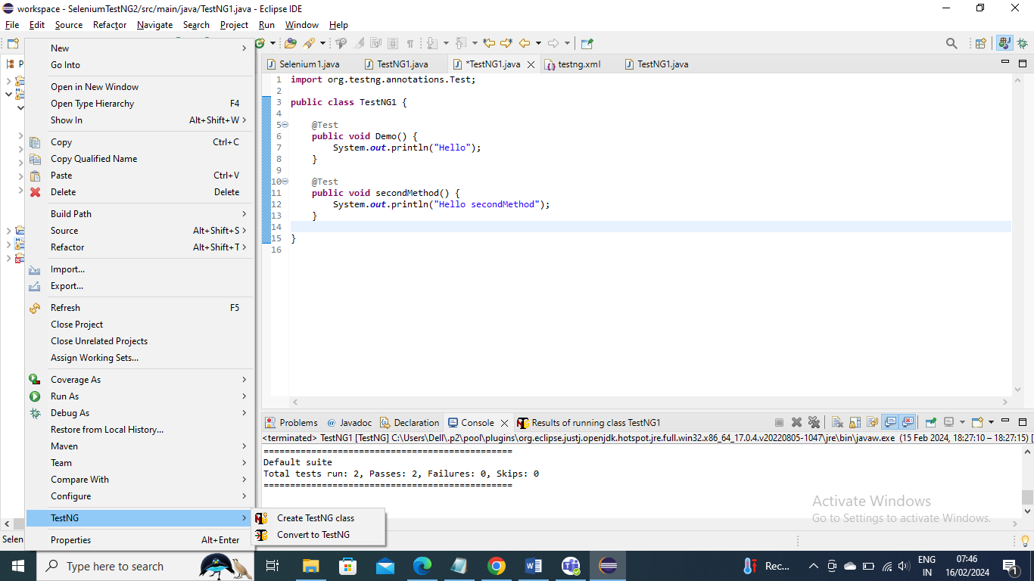

How to run test with TestNG?

You need to have @Test Annotation (first create TestNG class library and then import org.testNG…) followed by method and then Run as --- TestNG application

Below is an Example:

**import** org.testng.annotations.Test;

**public** **class** TestNG1 {

@Test

**public** **void** Demo() {

System.***out***.println("Hello");

}

}

You can define multiple tests from single class

Below is example

**import** org.testng.annotations.Test;

**public** **class** TestNG1 {

@Test

**public** **void** Demo() {

System.***out***.println("Hello");

}

@Test

**public** **void** secondMethod() {

System.***out***.println("Hello secondMethod");

}

}

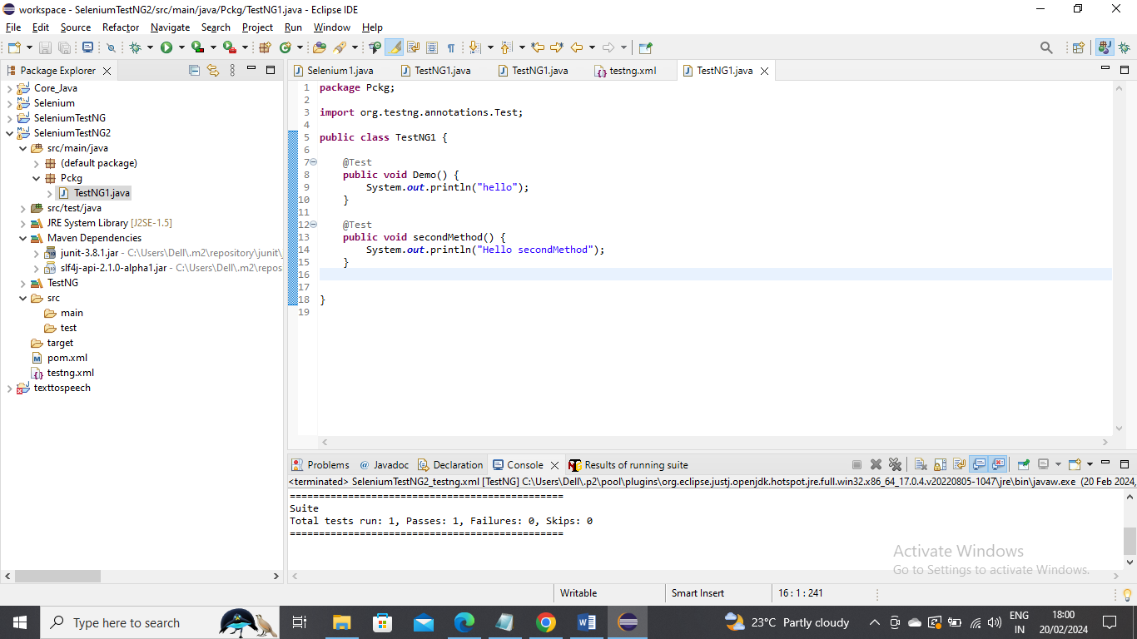

Example:

Running the tests using XML below is an example

Now create the XML as below,

Here Suite name is “First Example” you can give your own defined name and For test name as well you can give any and class name will be package_name.Class_name

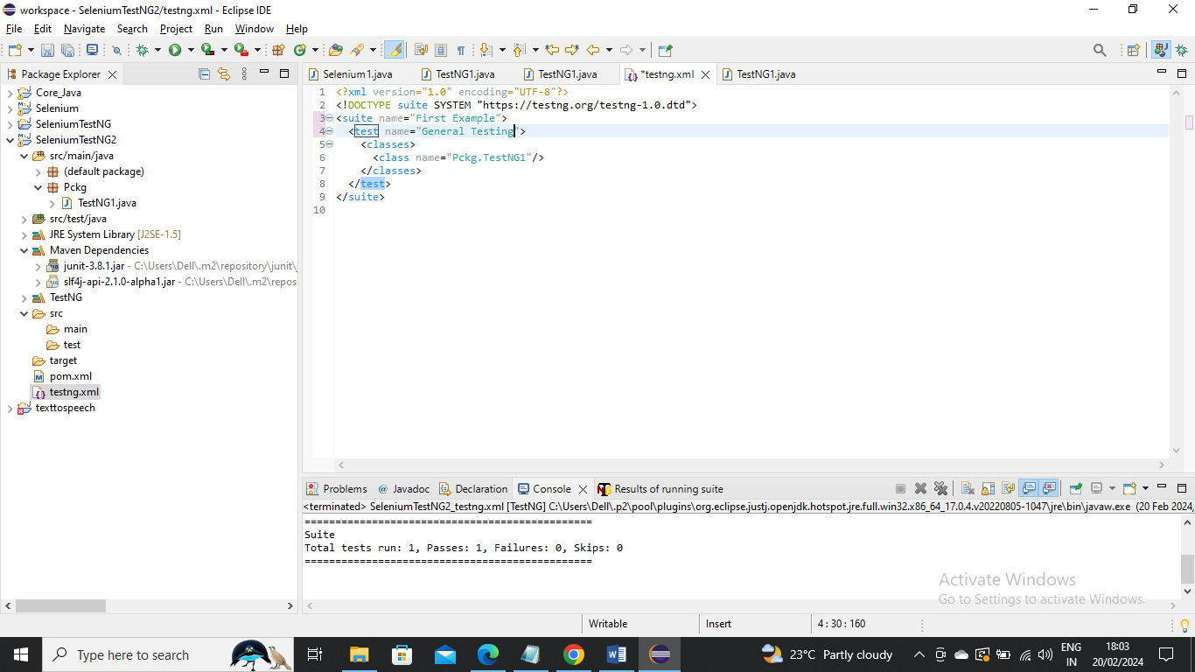

Now to run this….right click on project or XML and runs as “TestNG Suite”

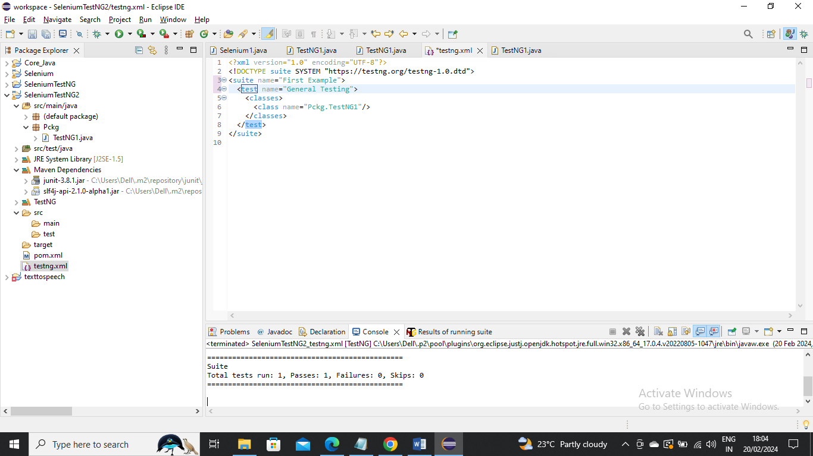

------------------------------------------------------

Example:

If you want to methods from another class you can just add another class in XML and ask to run that as well

Create the new class if not present

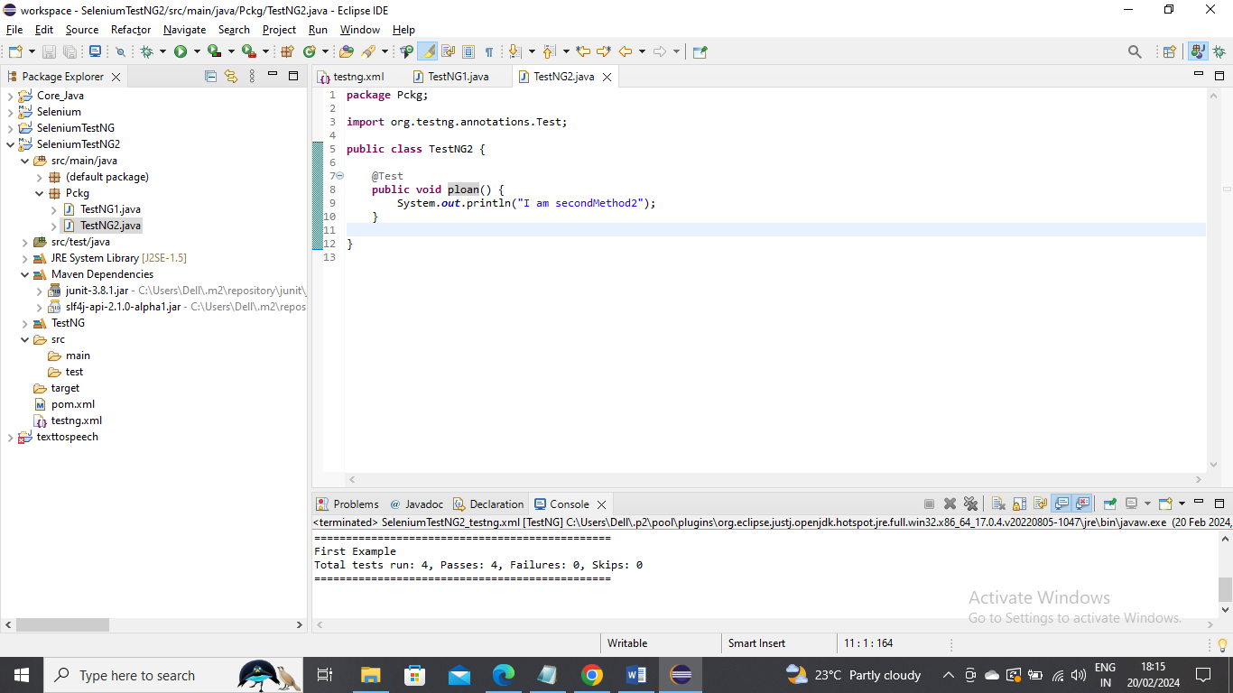

Now add that class name in XML and run it

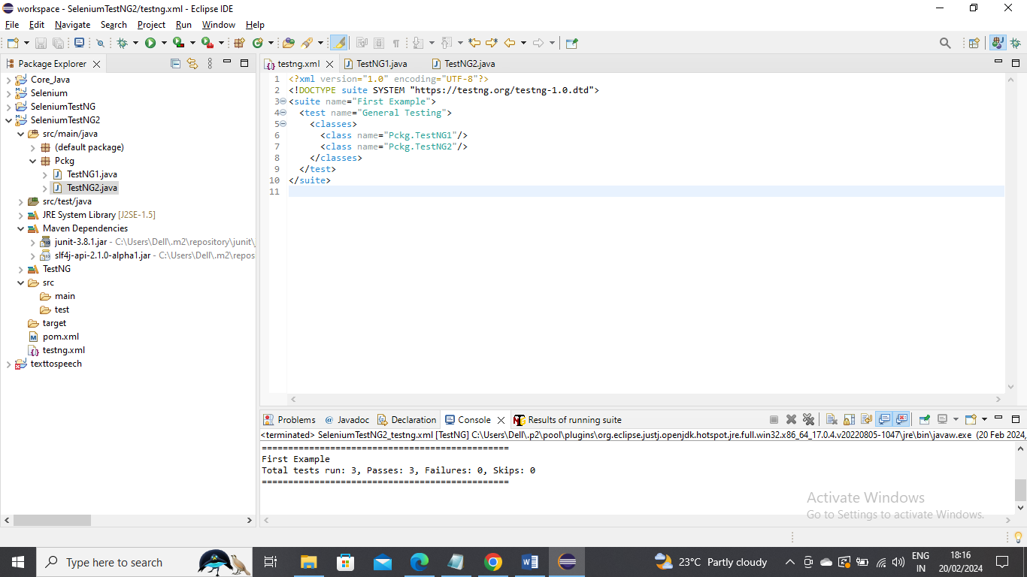

---------------------------

Note: How does we know which method execute first in a class. It gives priority based on alphabetic manner

Example:

If you have multiple classes say TestNG1 to TestNG4 and you want to execute all you can give all the appropriate class under test name and execute

Below are four classes

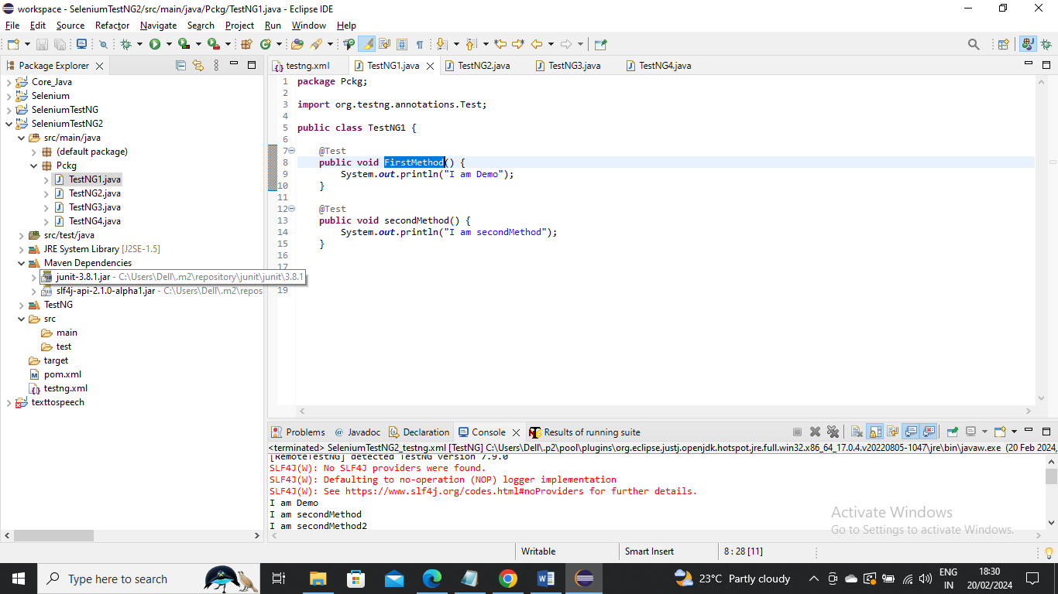

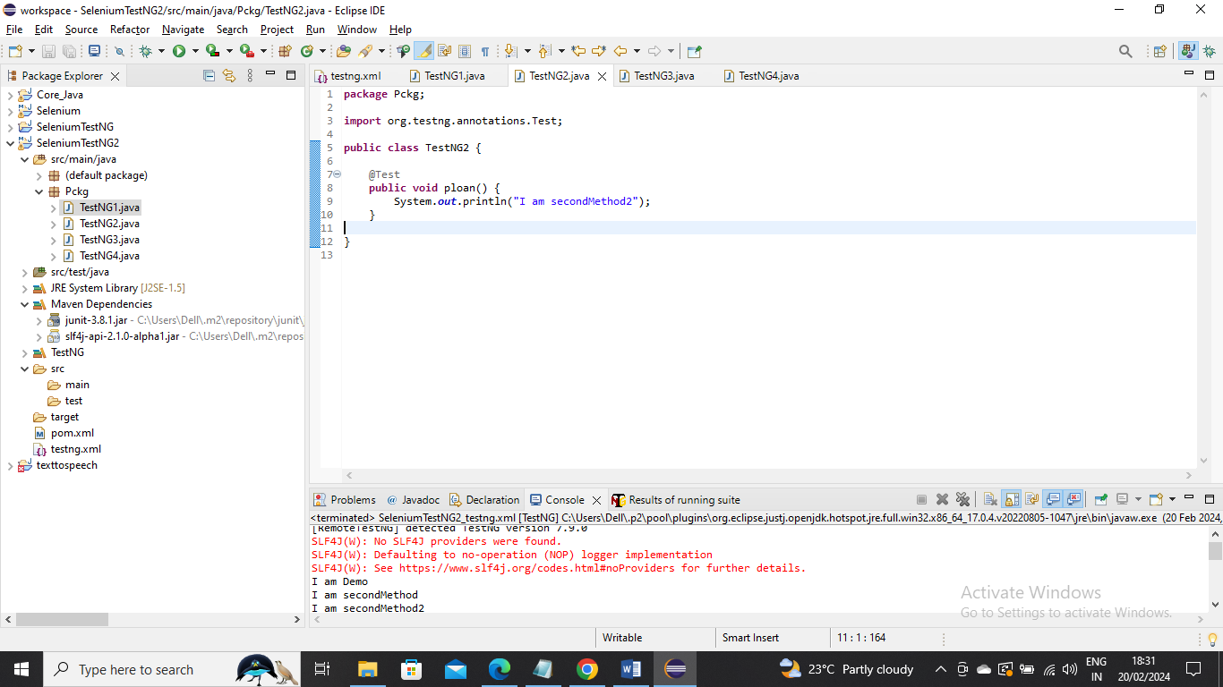

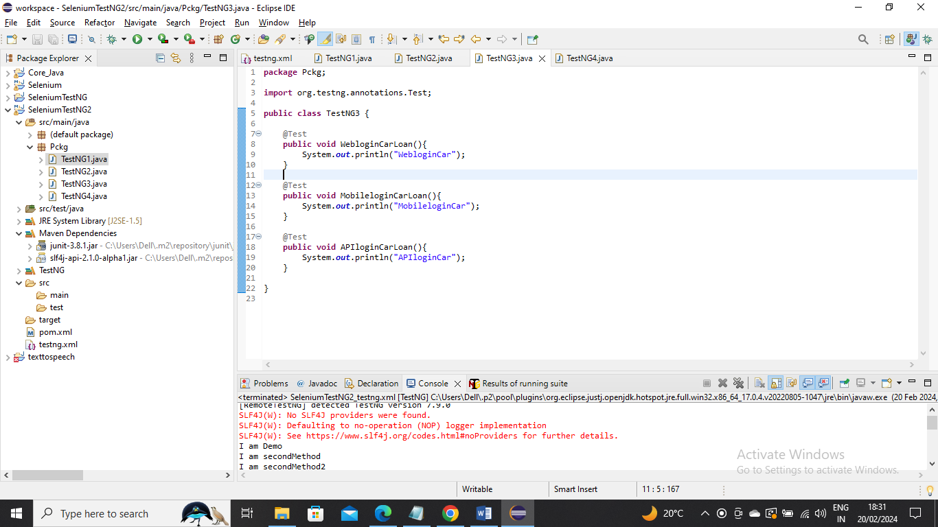

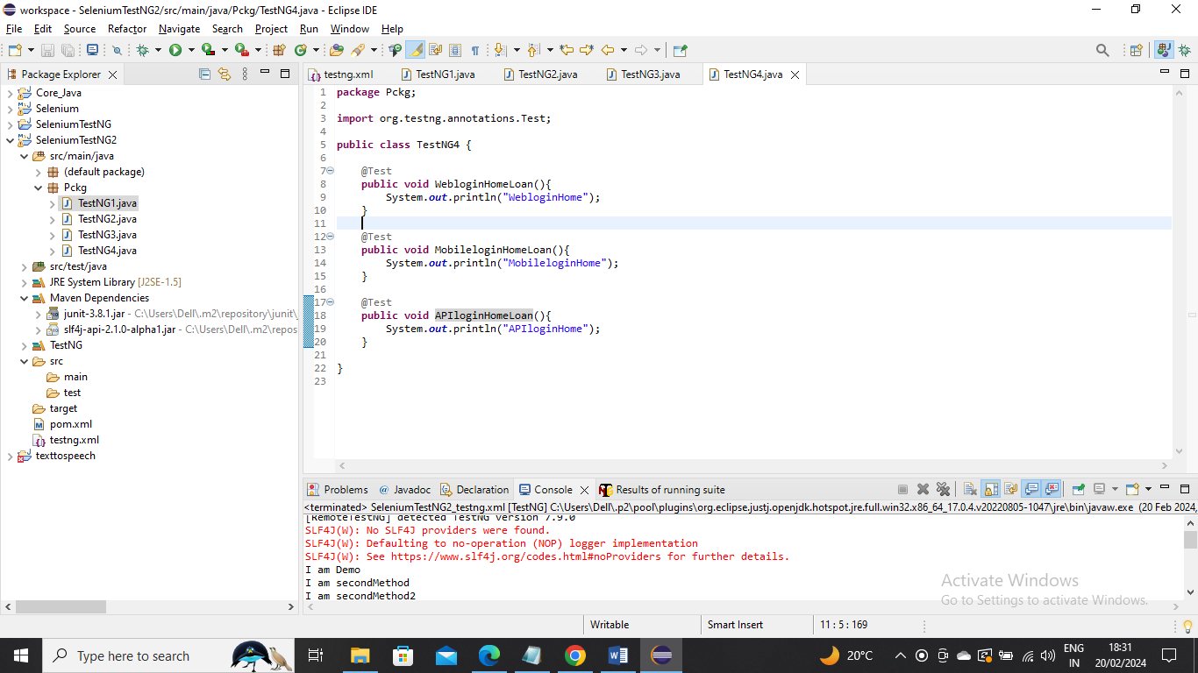

Below is the XML where you gave appropriate class under test name and execute

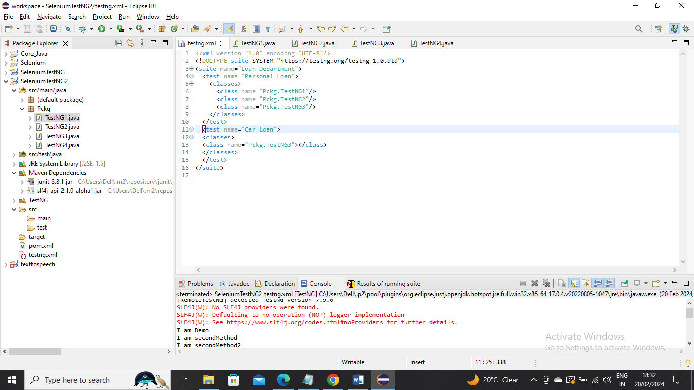

------

Example:

If you want to execute only one class then you can just provide that class only

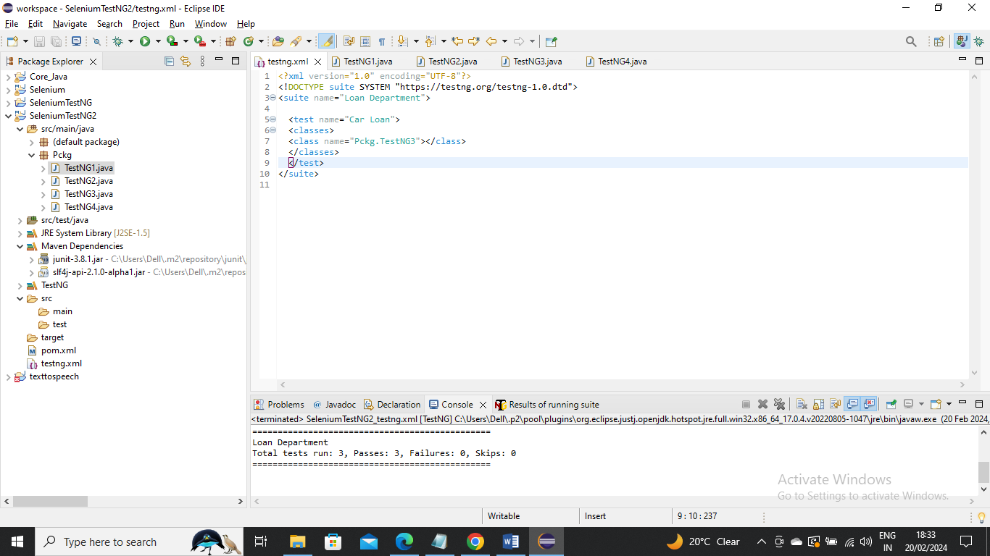

-----------

Example:

If you want to excluded or not run a specific method from class you can use exclude tag within methods tag to exclude that

In below we have excluded “MobileLoginCarLoan” method from TestNG3 class

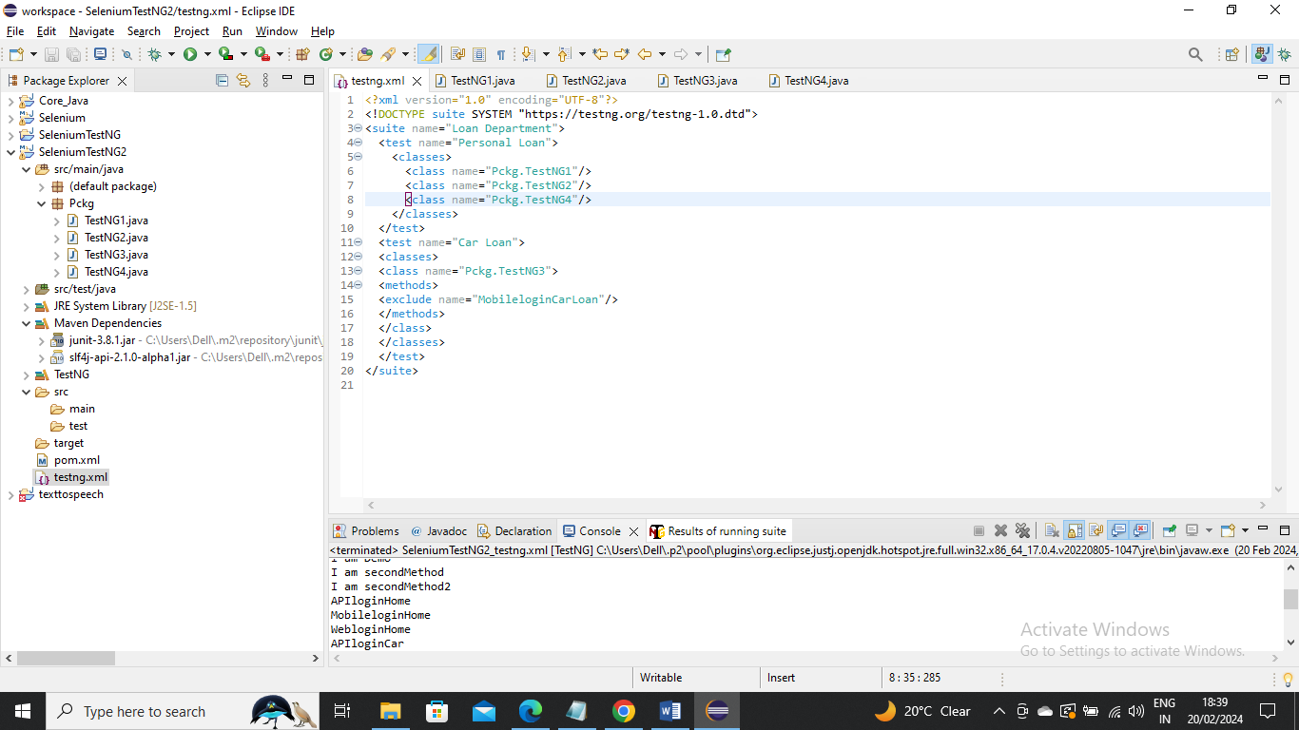

The above is useful when you want for example to exclude only one or two methods in class having 100 methods

-----------------

Example:

In a case where you have 100 methods in a class and you want only 1 or 2 methods to run? In that case when can use include tag in XML file

In below we want only Demo method to run from the class TestNG1 we can give as below

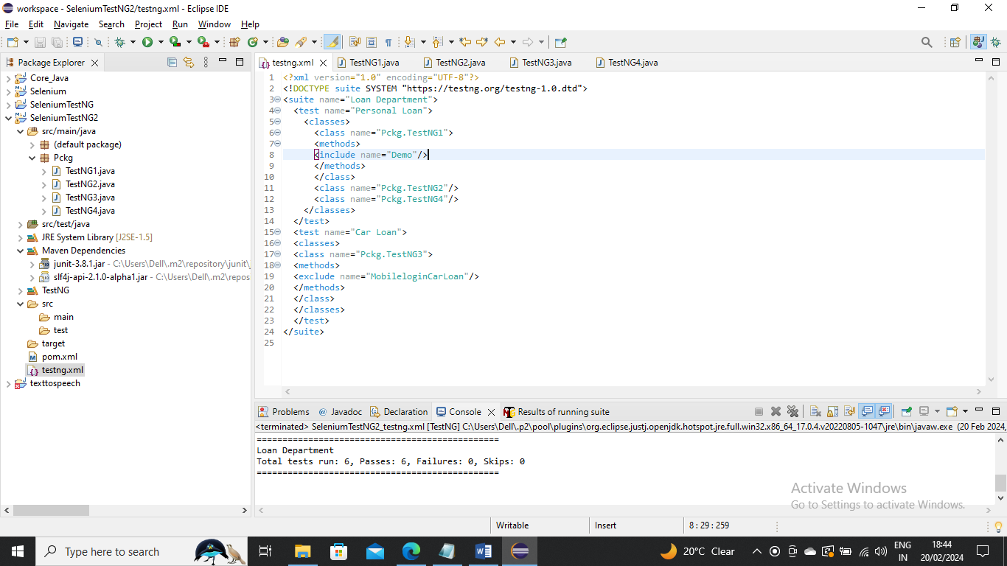

-----------------

Example:

In a case where you want to exclude all the methods starting with Mobile then in exclude name you can give Mobile.* Regex

Below is example



------------------

Example:

In a case where you want to execute everything inside a package you can do below give the package name here I have my package name “Pckg”

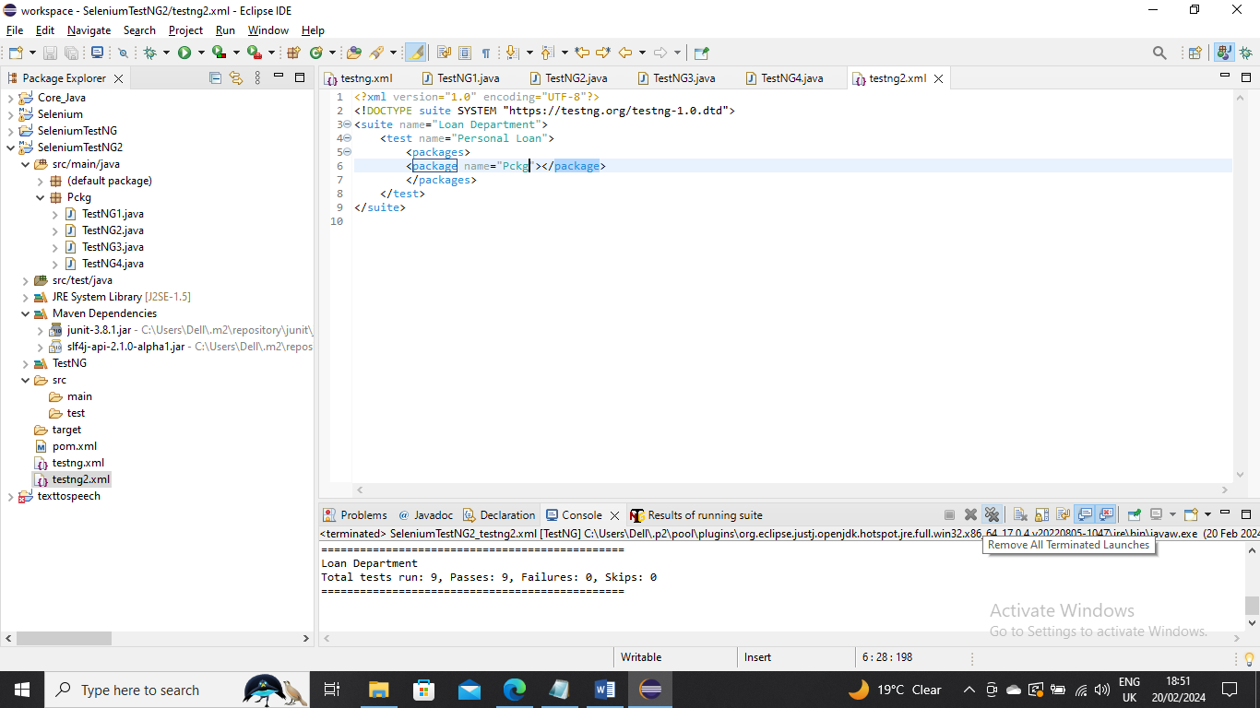

----------

Example:

In real scenarios there might be a pre-requisite for running a test case like cleaning up the servers or connecting to ports or anything then you want certain method to execute first always……here we can use “@BeforeTest” annotation for a method and it will execute at first

Also in another case where there might be need to close ports or end connections or something like that then you use “@AfterTest” annotation for a method and it will execute last

Below are the classes havinf both annotations

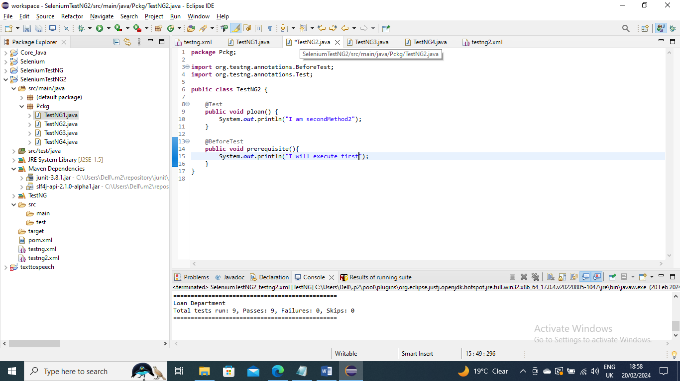

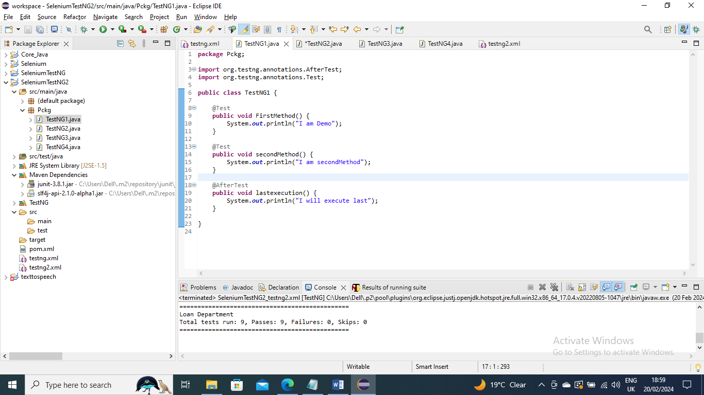

Below I have used entire package to execute



---------------

Example:

Before running the suite you want to set certain variables or URLS or something then you can use @BeforeSuite annotation it will execute at the start of Suite…………..In same way in a case you want to close URLS or something you can use @AfterSuite

There comes question how it is different from @BeforeTest and @AfterTest…….there may be many Test class in a suite…..But there is only one suite in a XML. So you can have multiple @BeforeTest and @AfterTest for a suite in XML but @BeforeSuite and @AfterSuite will be only one in Suite

Below are @BeforeSuite and @AfterSuite annotations in class

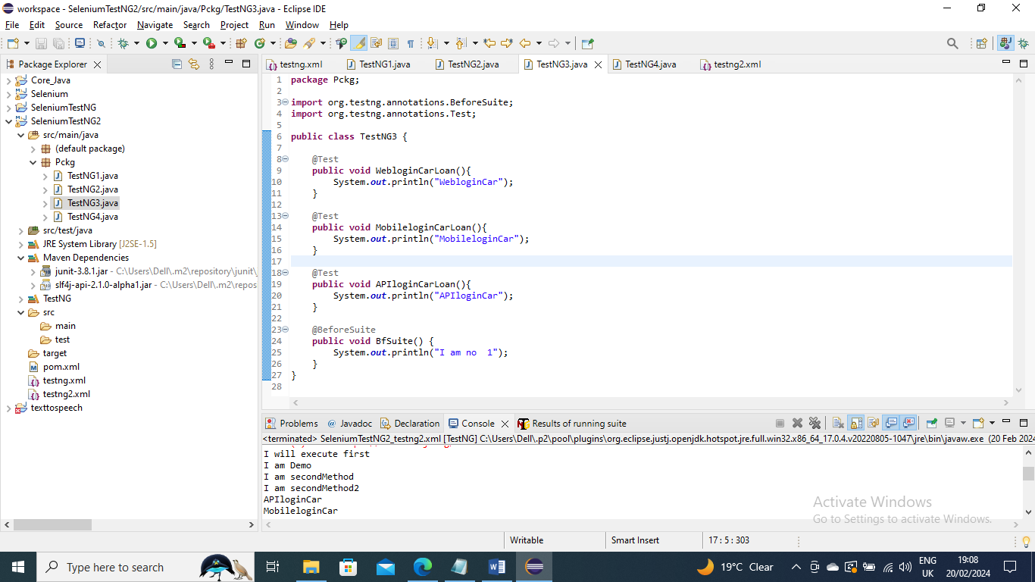

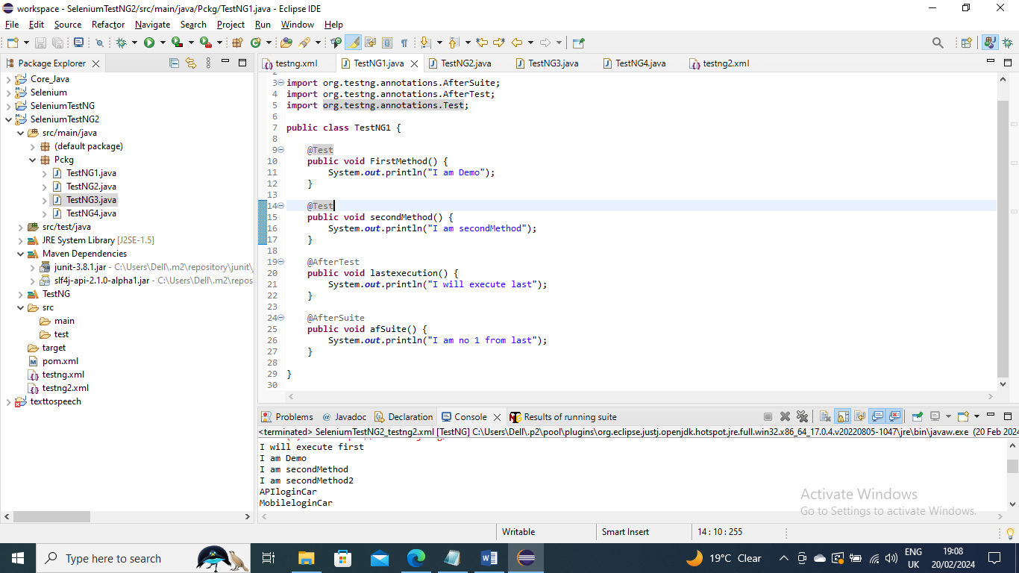

Below is the XML used to run

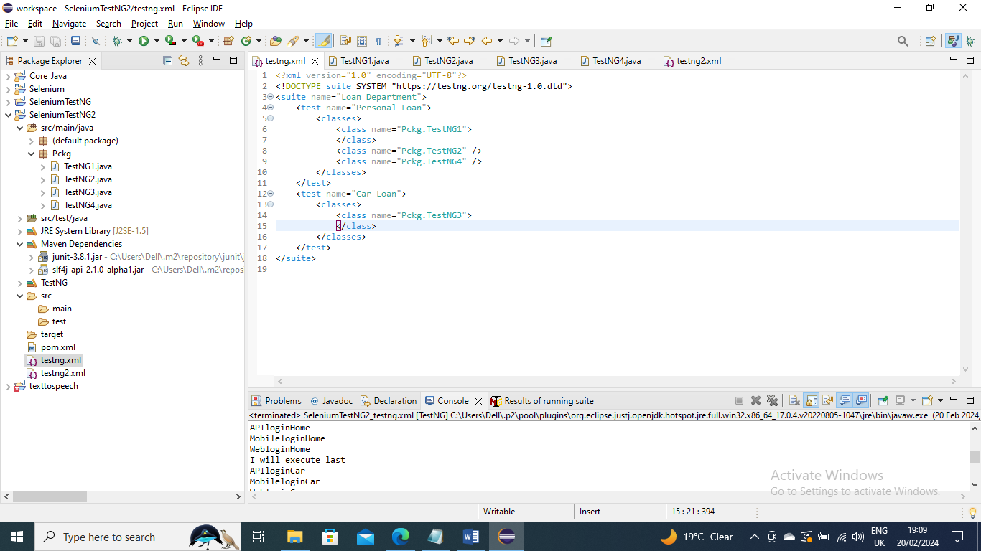

----------

Example:

We can use @BeforeMethod and @AfterMethod if there is a scenario where you need to open connection and close connection for each method gets executed

Note - @BeforeMethod and @AfterMethod are specific to class not to test and Suite that means the scope is just inside that class

Below are the methods in TestNG3 class for all CarLoan methods these two methods get executed first and last ……You can just singly use @BeforeMethod or @AfterMethod as per requirement . I just did both for my notes

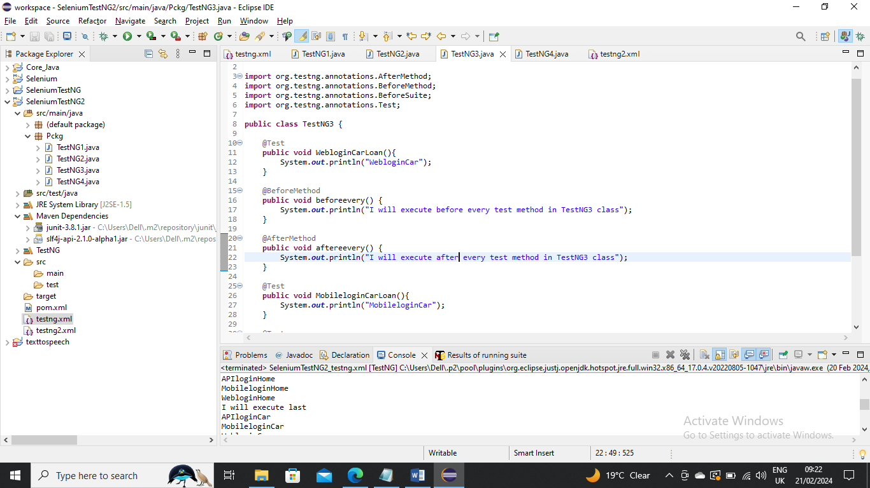

Now execute using XML as usual

--------------------

Example:

We can use @BeforeClass and @AfterClass if there is a scenario where you need to open running something when this class gets executed and run once all methods in class got executed

Note - @BeforeClass and @AfterClass are in scope only for that class

The difference between @BeforeClass and @AfterClass and @BeforeMethod and @AfterMethod is method(agfeter and before) will execute for each method run while class(after and before) once when the class get runs. There are may scenario like you wants something to on when class gets run and when close when all that methods in that class gets finished

Below are the methods in class

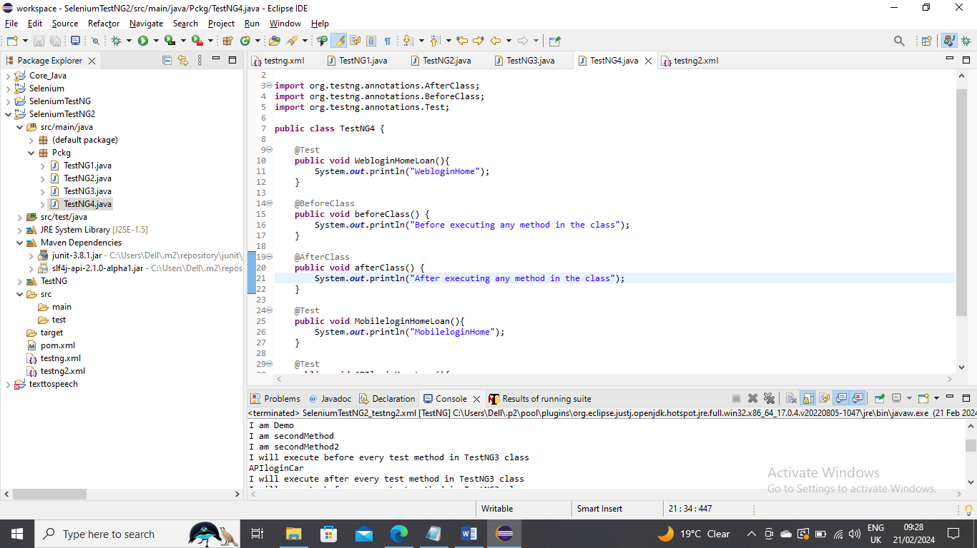

Run XML as usual

--------------------------------

Example:

There may be a case where you need to do a small daily run or something where you need to run specific methods from 100’s of classes then you can use Groups for it

Below is the methods in 4 classes I made to groups

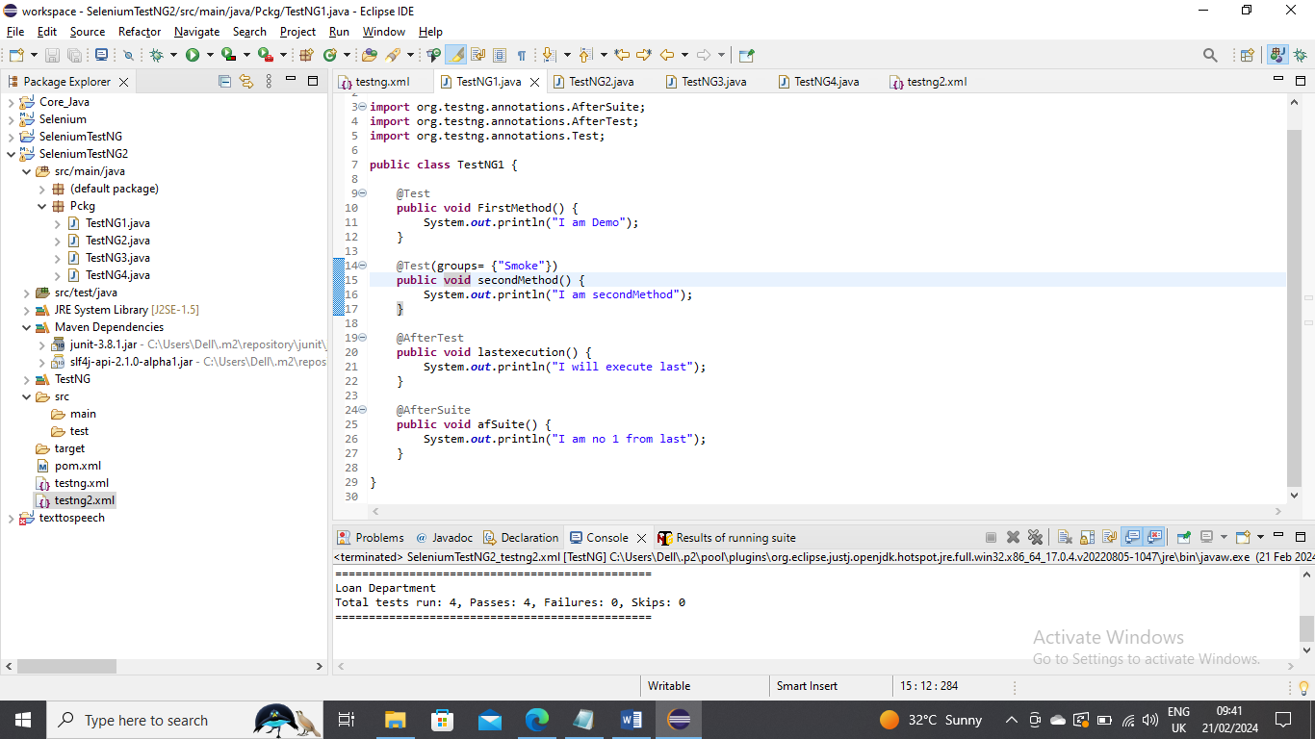

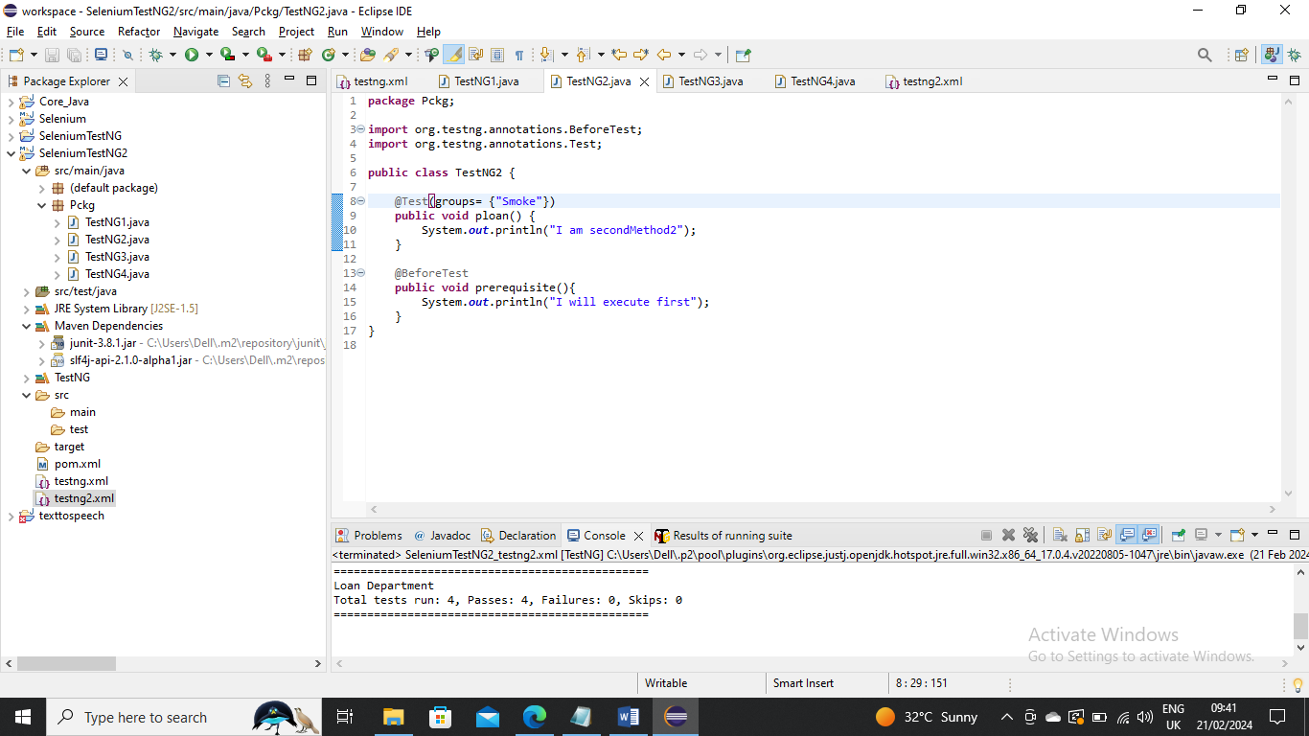

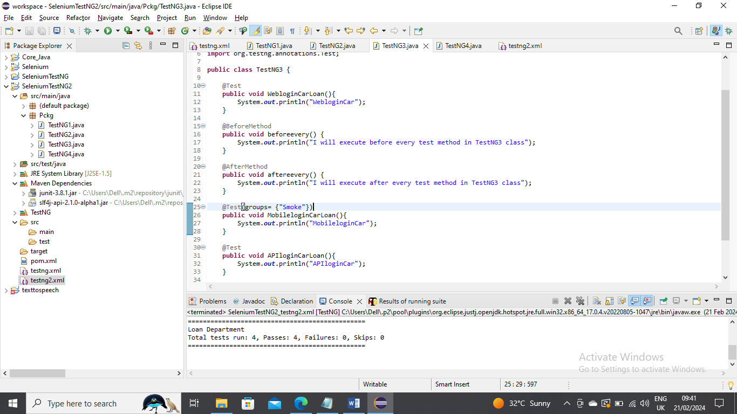

Now make changes in XML as below where you mention which needs to run under group name and execute

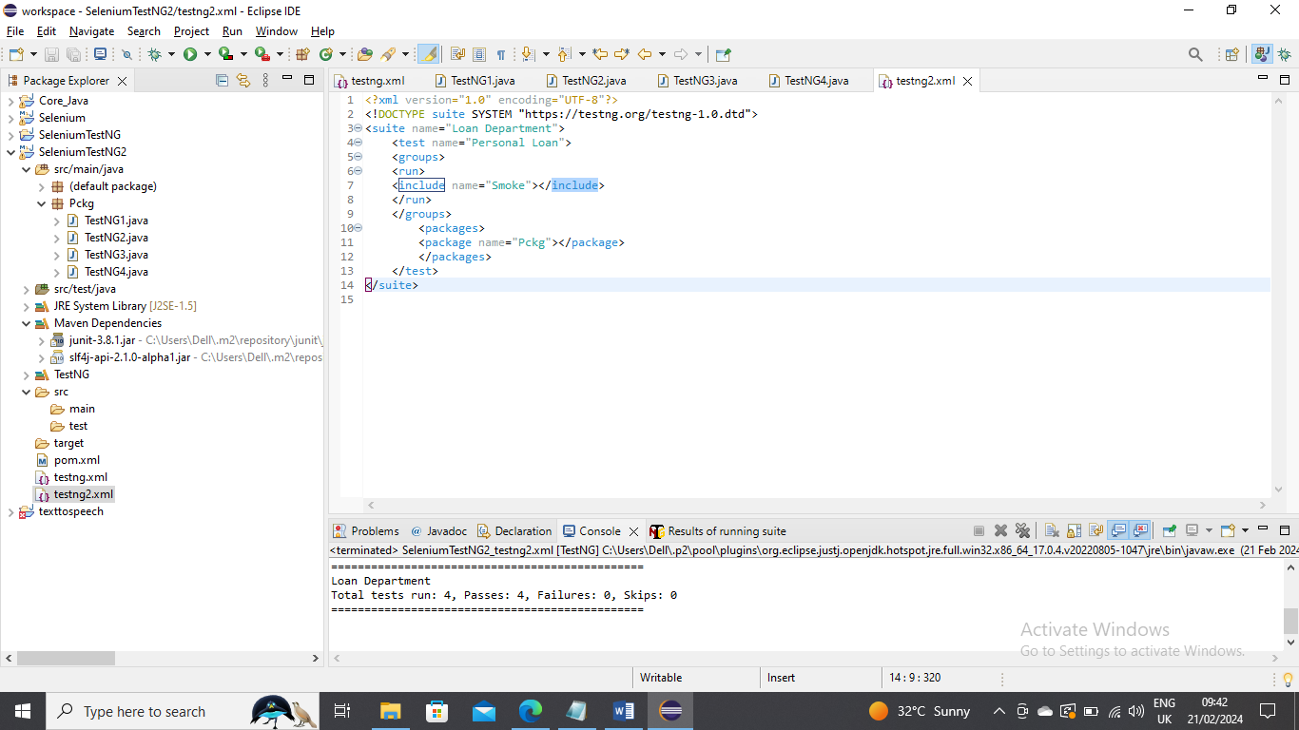

-----------------------

Example:

In a case where you need to run all methods except smoke then you change from include to exclude as below and run

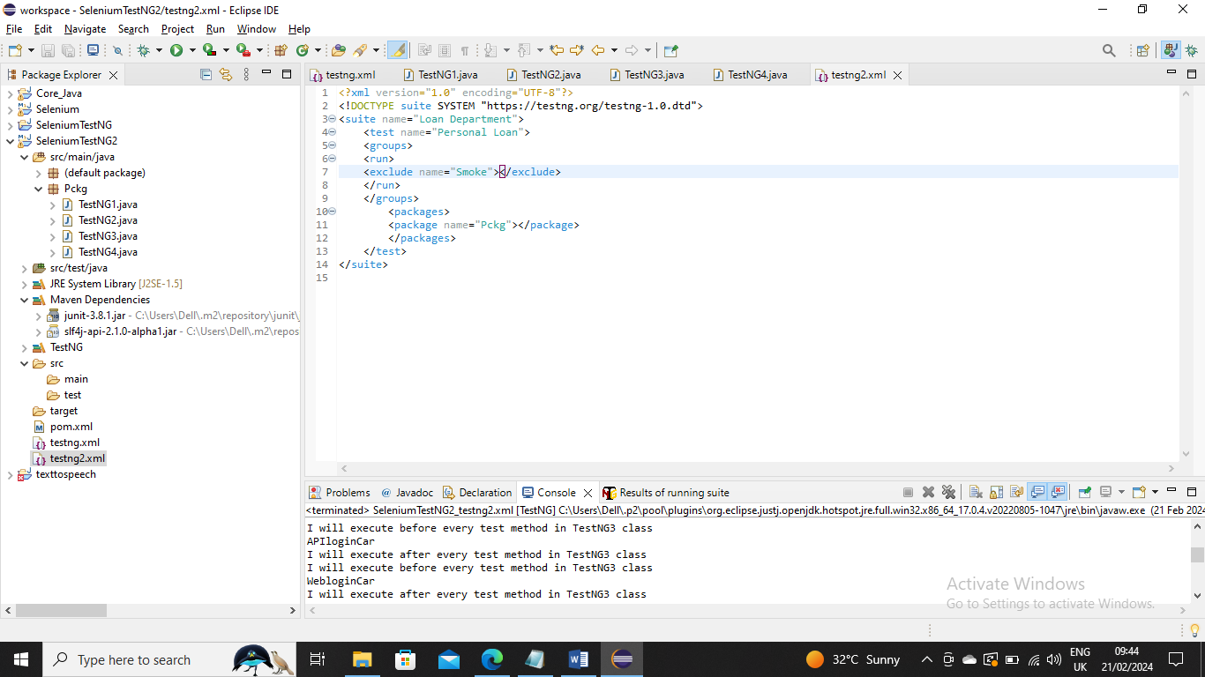

------------

Example:

There is a scenario where you need to run a specific method before another specific method is run in that case you can use Depends

In below method APIloginCarLoan is dependent on WebloginCarLoan method where runs APIloginCarLoan only after WebloginCarLoan

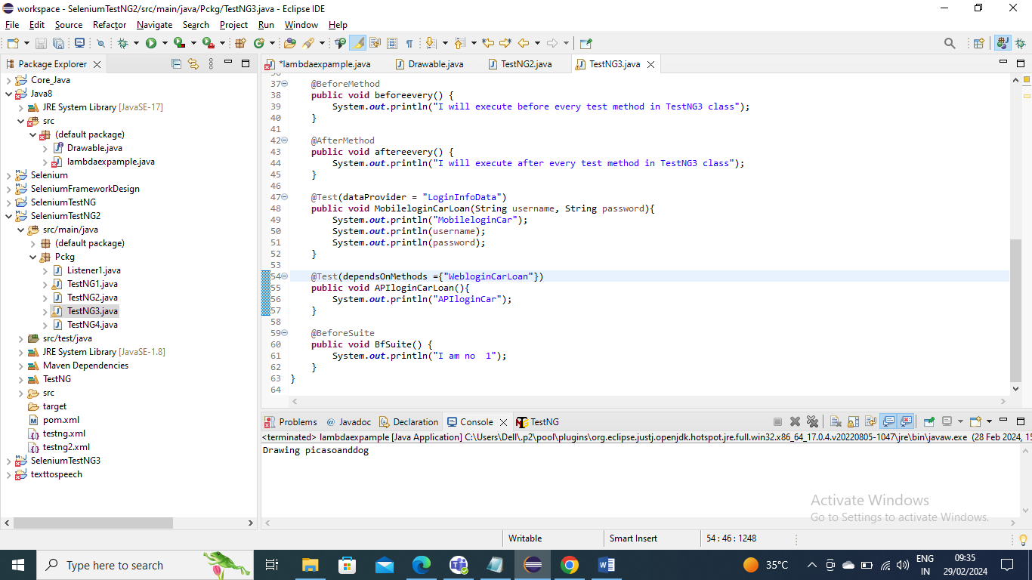

Run XML as usual

-----------

Example:

In a case where two methods are dependent for a specific method then you can add that method name in depends.

Now which two of depends run first it is based on alphabetic. In below Mobile runs first and later Web since M letter is first

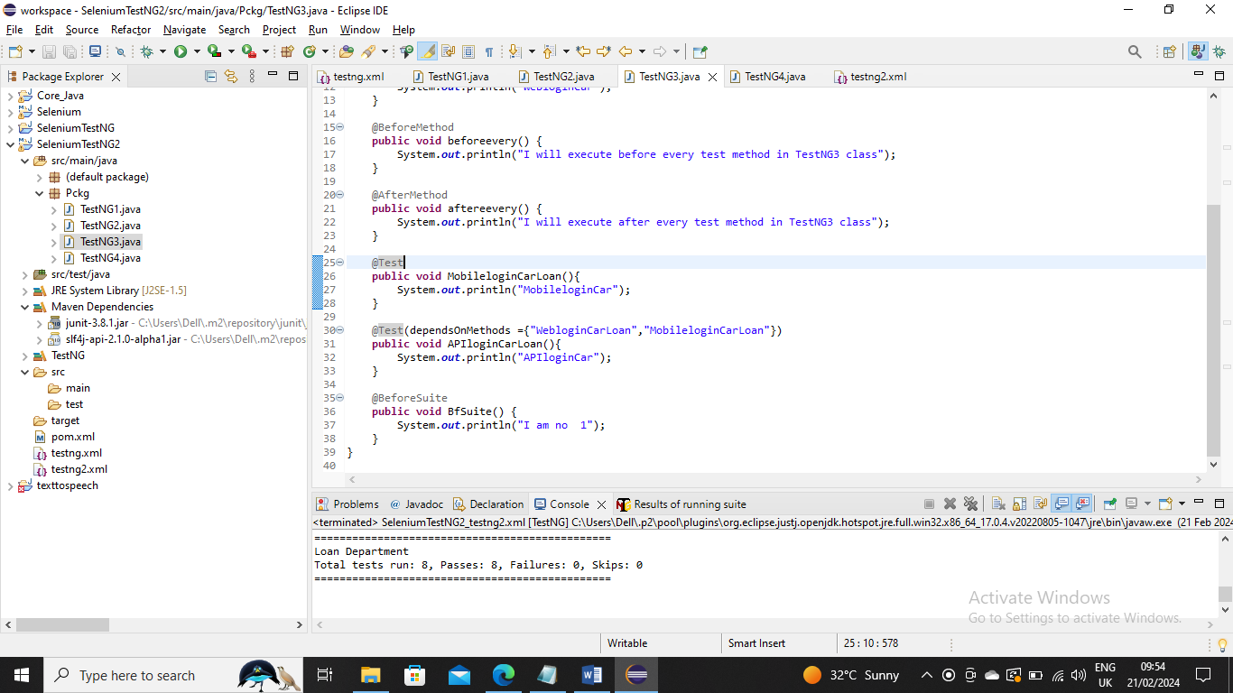

Runs XML as usual

----------------------

Example:

In a case where certain method is not working or having bug and you don’t want to run in regression run or full run you can just say enabled=false and that method will not run Below is the screenshot where FirstMethod is enabled to false so that it won’t run

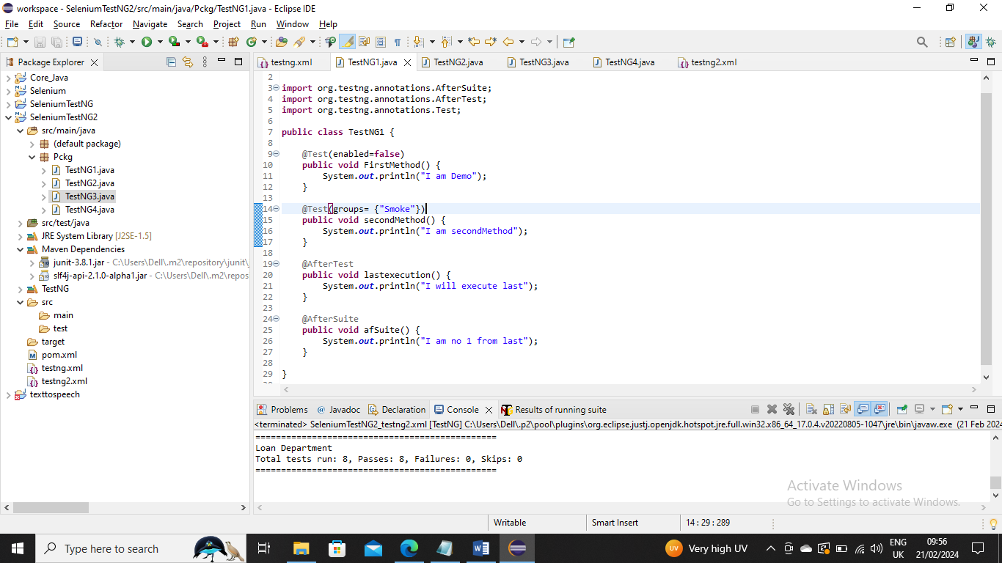

Run XML as usual

-----------------

Example:

There is a case where Mobile Login is taking more than 40 seconds and due to which that methods is getting failed. You can make the method not to fail until 40 seconds after that even its loaded it will fail

Below I made it 40 seconds not to fail

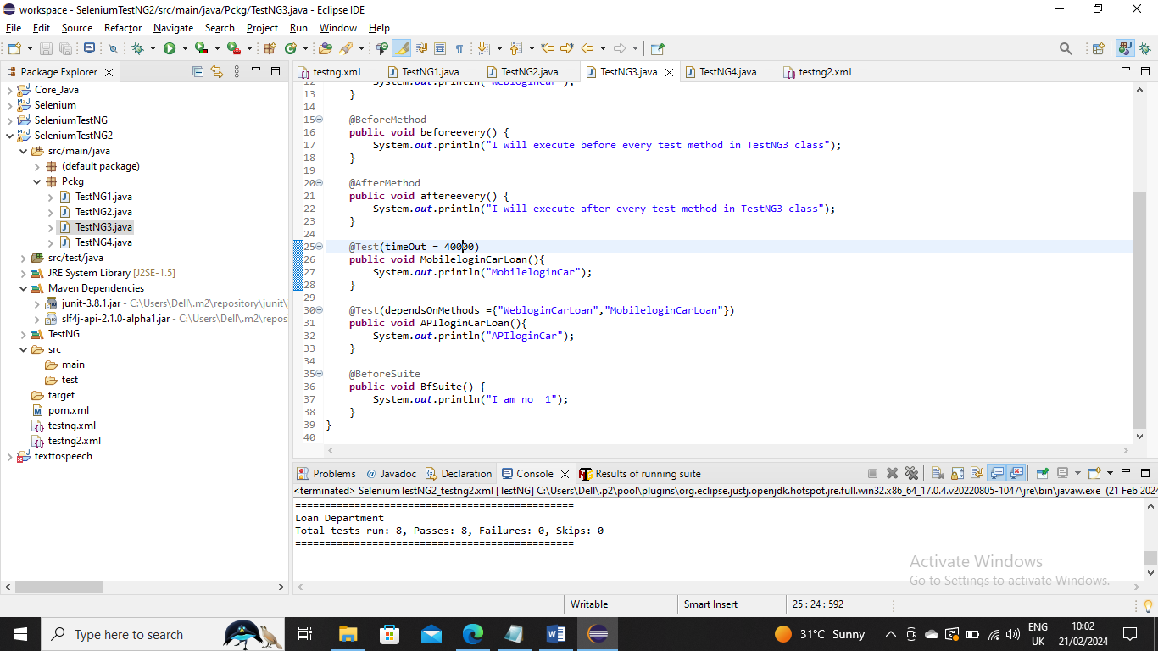

Run XML as usual

-------------------

Example:

There is a case where you need to pass parameters to method you can do it by using “Parameters and giving the details as below and create an argument and retrieve it

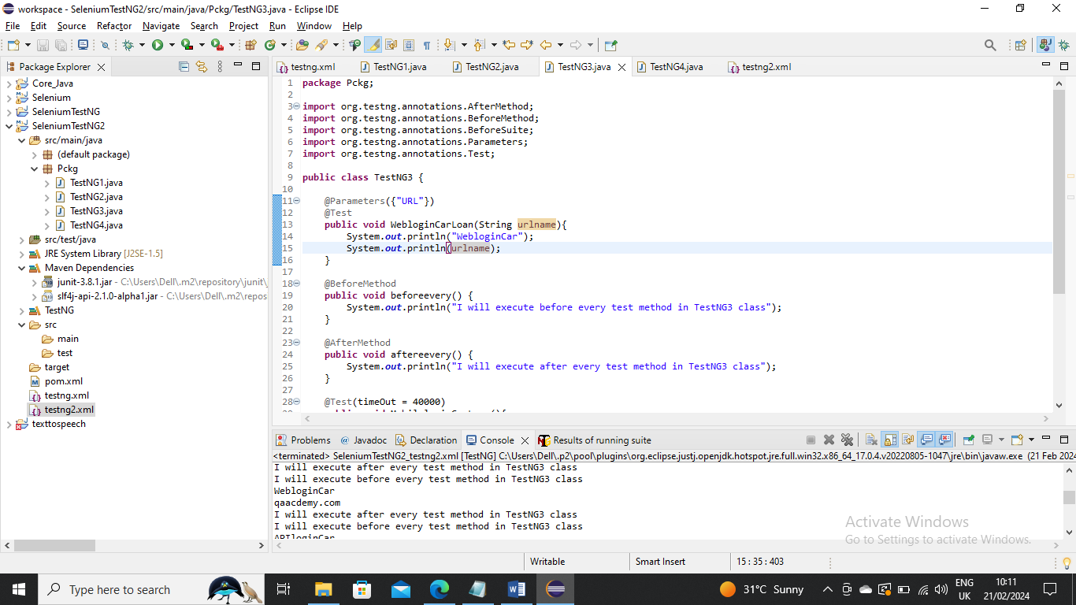

Use XML and create parameter tag and give the name and value and run it

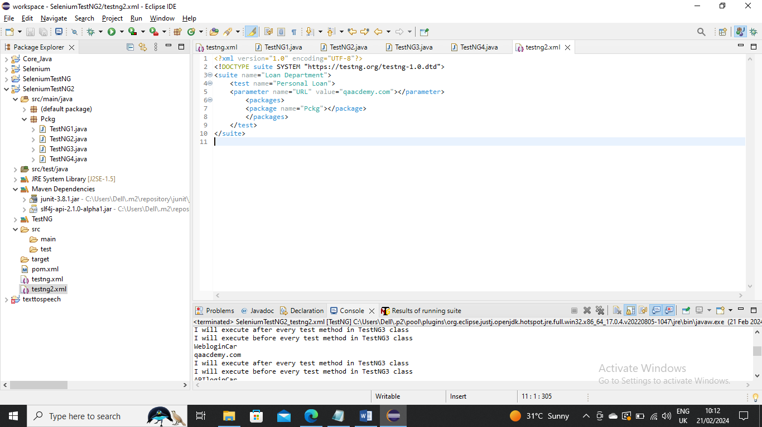

The parameter can be written for a suite , Test or class as well. For example if you write inside Test the scope of that value is for that test

In below I have made another parameter URL1 in TestNG1 class below is screenshot

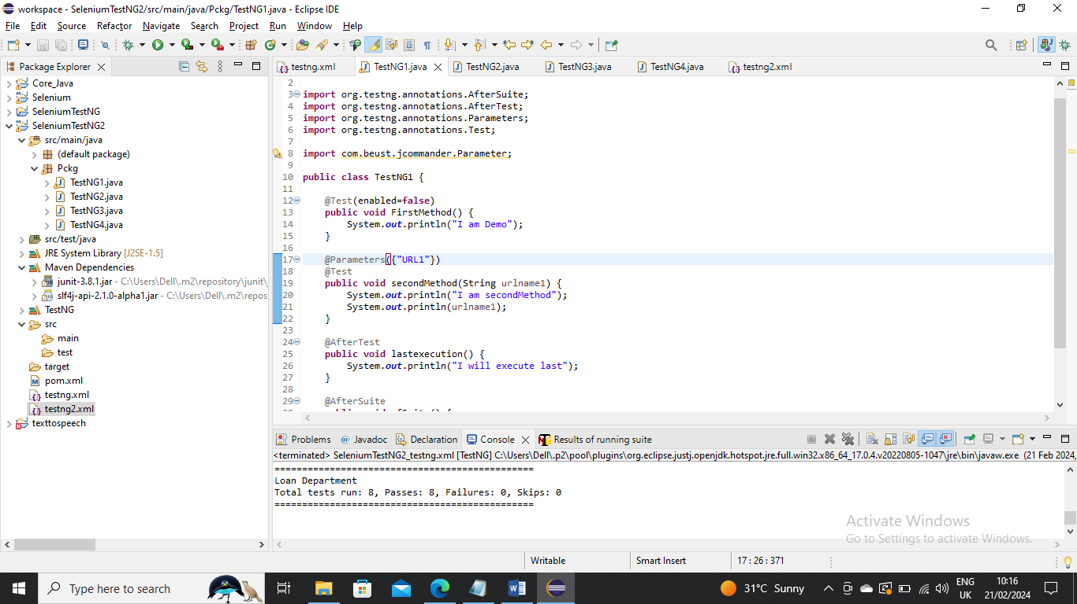

Now I passed different value from one Test and different value to TestNG3 from another test .To differentiate or tell that name need to be same I made URL and URL1 you can give same name as well

Below is XML to run

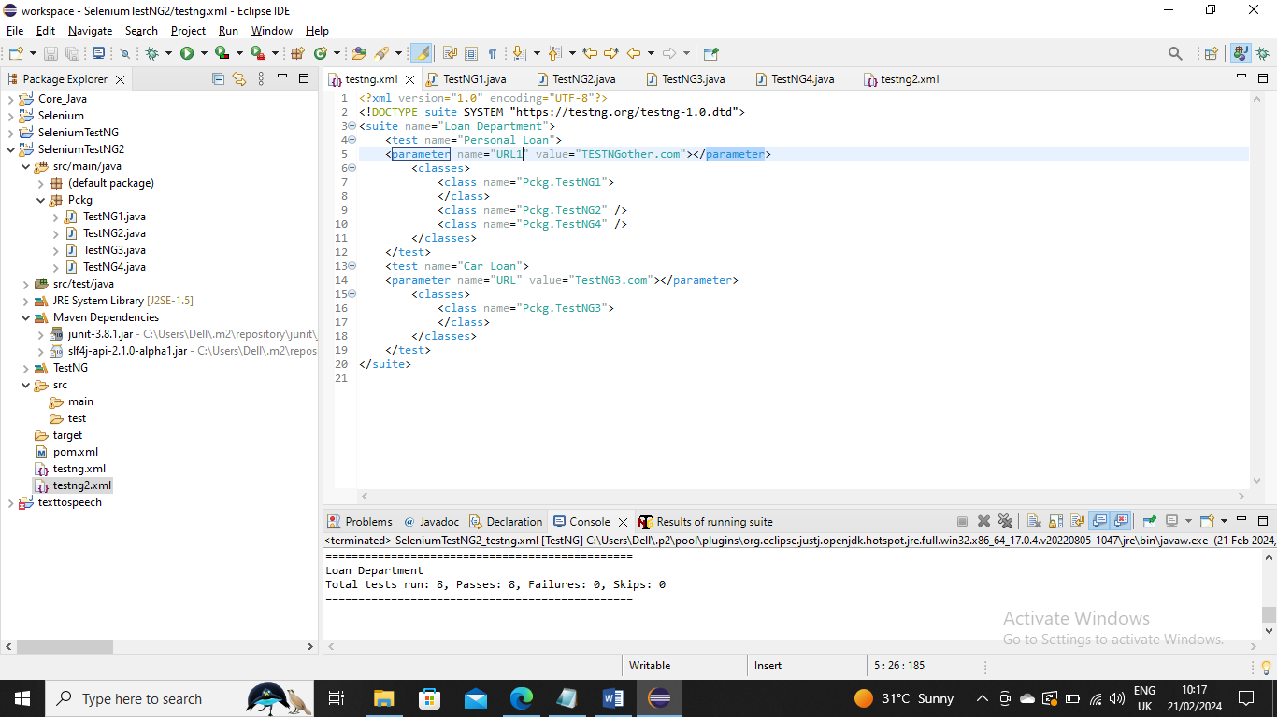

----------------------

Example:

In a case where you need to pass multiple paramaters to a method you can do same like below

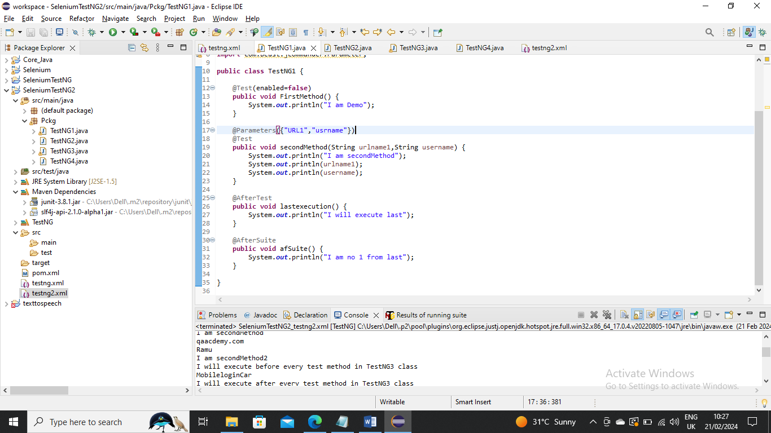

Run the example by providing two parameters

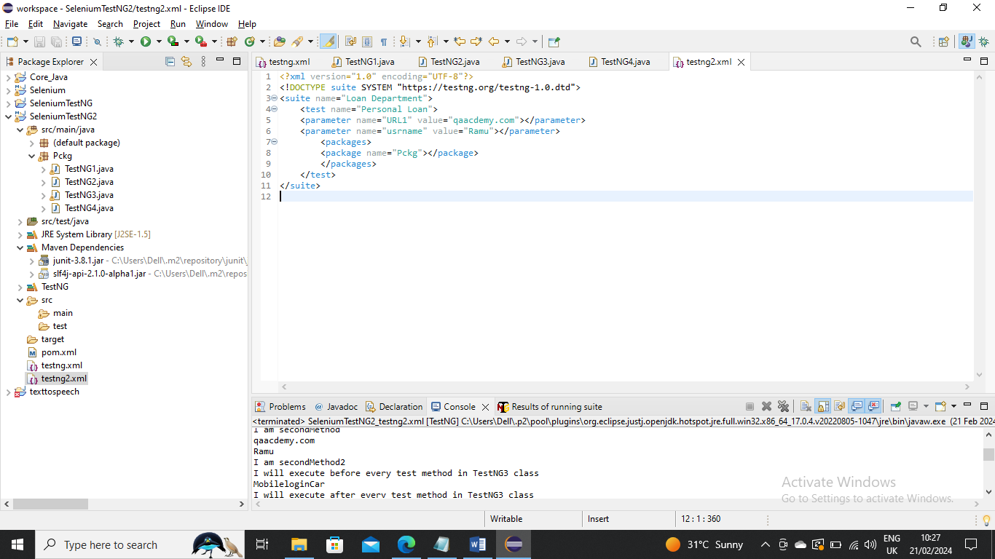  
---------------------------

Example:

There may be a scenario where you need to pass parameters (multiple usernames and passwords say) to a method for log in. You can do the same using DataProviders

In below a Dataprovider LoginInfoData has been created where an array sends multiple username and passwords to method MobileloginCarLoan

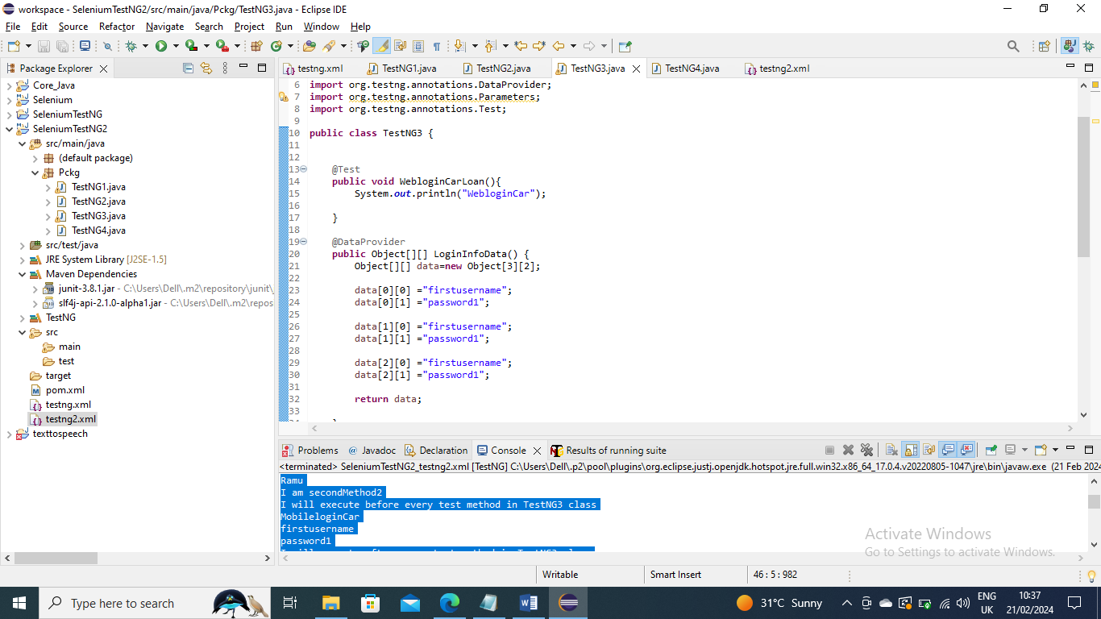

Now the values are picked as below by giving data Dataprovider name using Test i.e. Dataprovider = that name of method where parameters are sent from

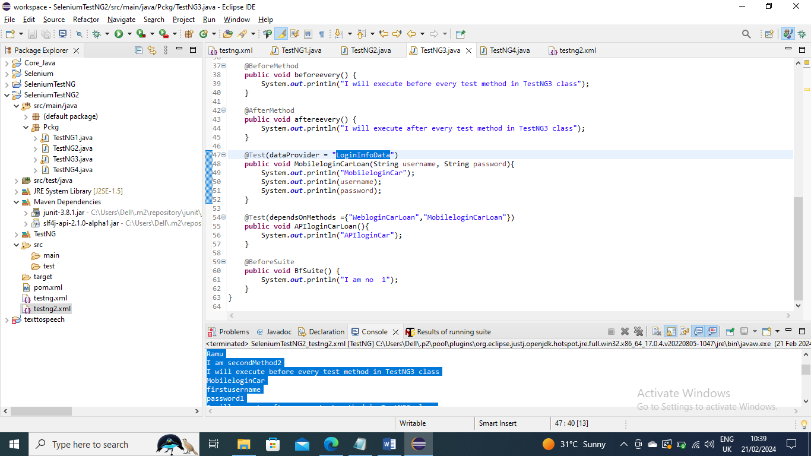

Run the XML as usual

-----------------

Example:

You can get whether a method got passed or failed using(implementing) the interface ITestListener

Create a class and implement ITestListener and override unimplemented methods like below

In below I am printing the below message for every successful method run

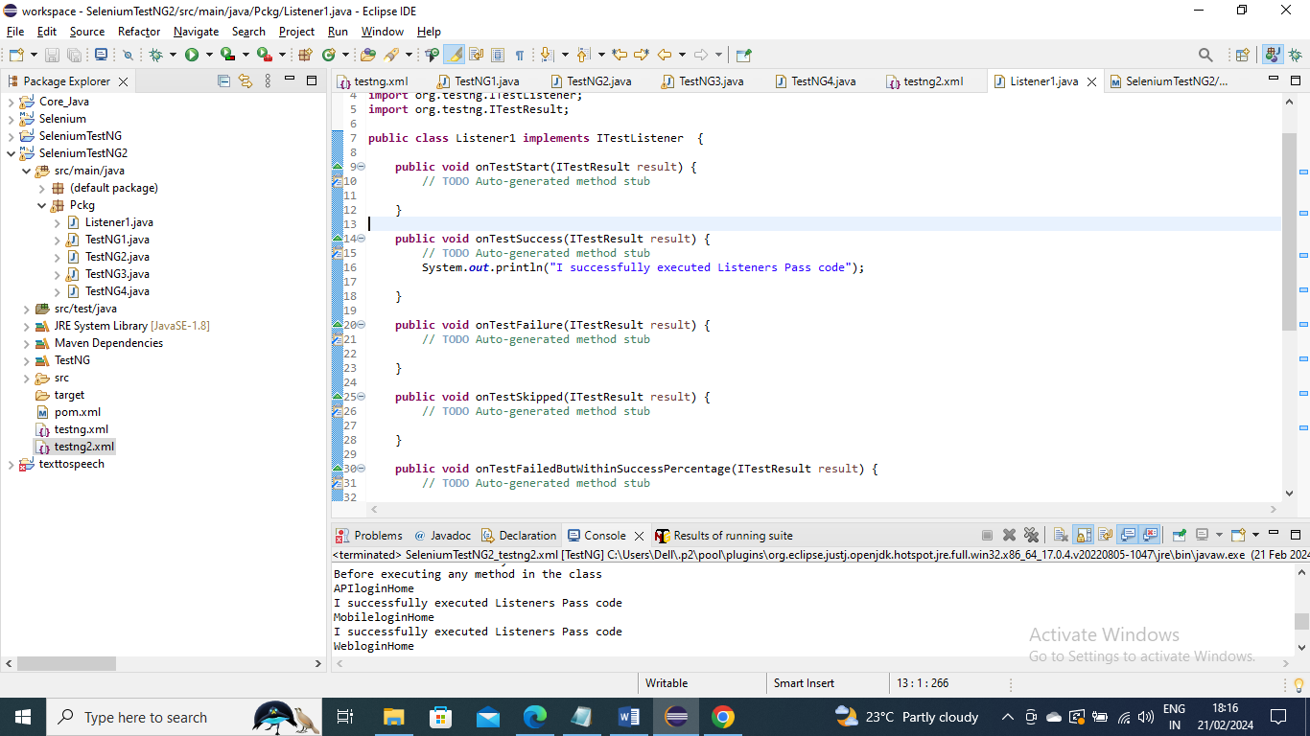

Below is the XML on how to tell the XML and other files which is the Listener class and run it

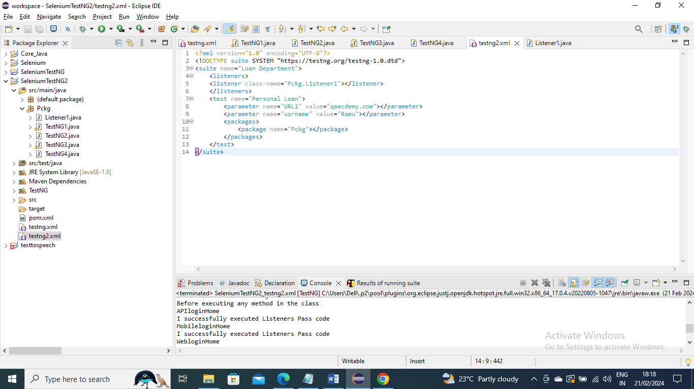

---------------------

Example:

In same way like above, You can create some sysout message for “OnTestFailure” and if any method gets failed it will print that given sysout message or info

I intentionally failed in below for Demo method

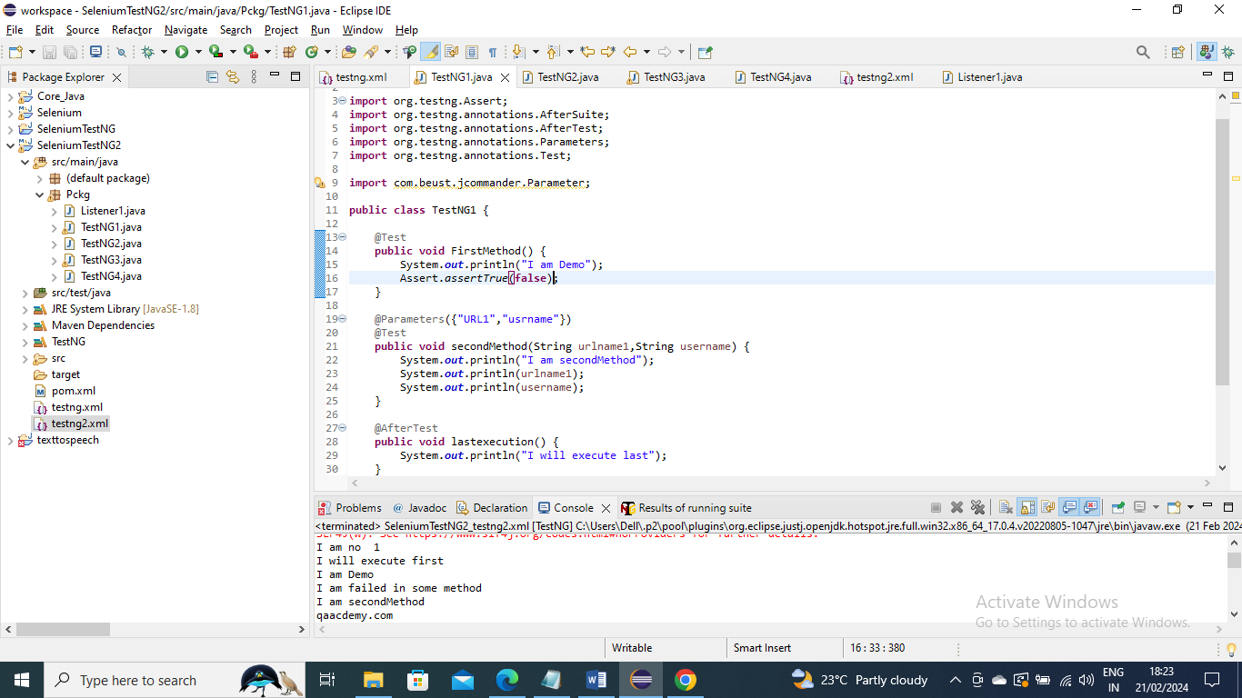

And run XML as ususal like above

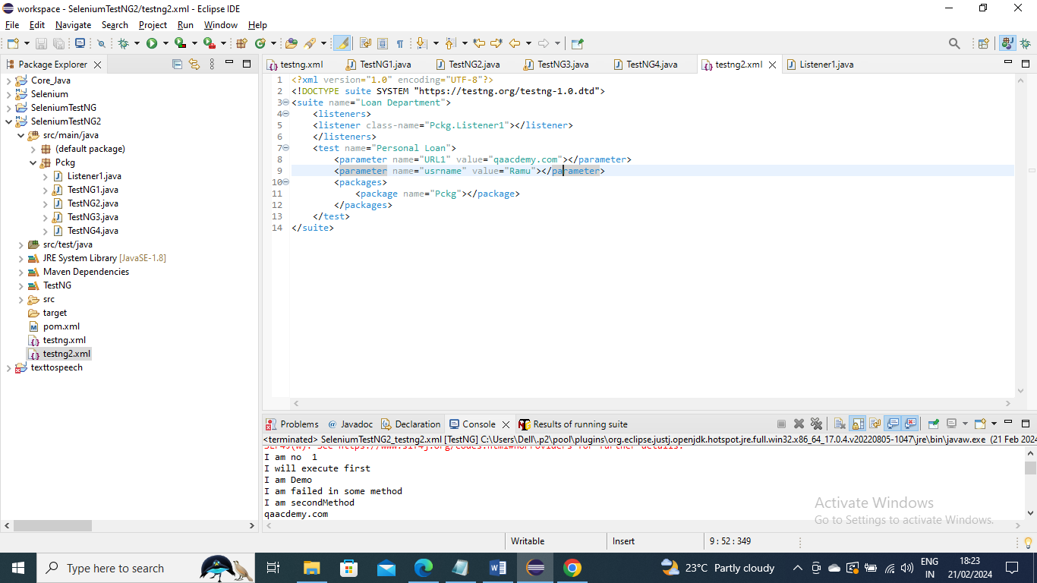

--------------------------

Example:

You can get which method got failed info as well for above by getting the name like below

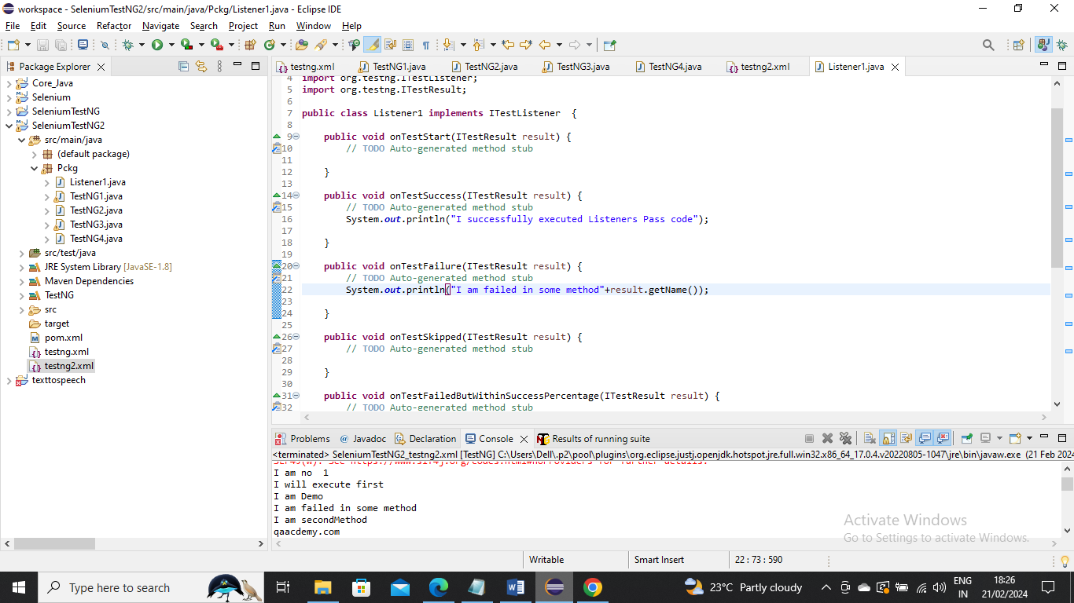

Now run XML as above used and you can check the method name in comsole



-------------------------------

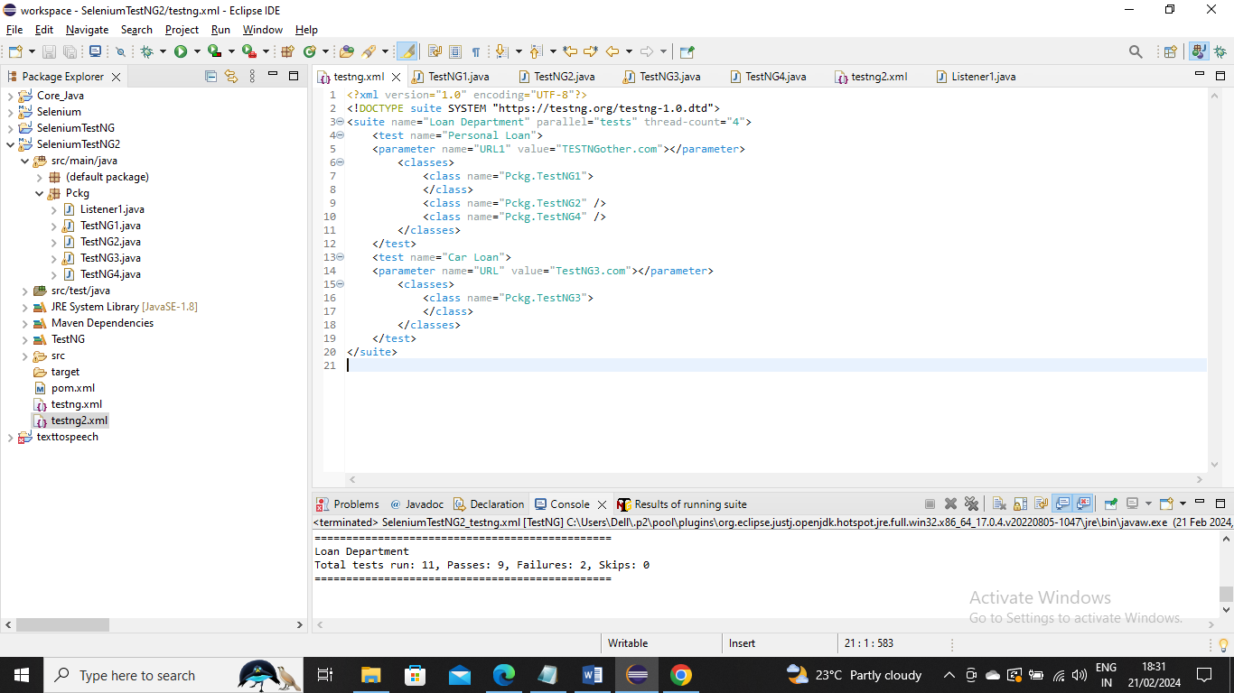

Note- Generally speaking it is not good practice run in parallel

Example:

In case where you can to run test cases pararallely you can running parallel giving like below info like Parallel=”tests” and thread-count which is saying how many tests you want to run in parallel